FACULTY EVALUATION SYSTEM
System Documentation

Jezreel Blanza
Rodjean Sotoza
Joshua Gacias
Jester Louie Pabustan

Course/Section: BSIT 2A

Instructor: Frank Jhondelf Mangulad

Date Submitted:

Introduction
The Faculty Evaluation System is a web-based application developed to streamline and improve the process of evaluating faculty members. The system replaces traditional paper-based evaluation methods with a centralized digital platform that enables students to submit evaluations efficiently while allowing administrators to manage records, monitor evaluation results, and generate reports.
The primary purpose of the system is to provide an organized, secure, and efficient method of collecting and processing faculty evaluation data. By automating the evaluation process, the system minimizes manual work, reduces the possibility of data loss, and improves the accuracy and accessibility of evaluation records.
The system is intended for administrators, who manage faculty and student records, monitor evaluation activities, analyze results, and generate reports, and students, who securely log into the system and submit evaluations for their assigned faculty members.
The system addresses slow data collection, time-consuming report generation, inconsistent record management, and difficulties in analyzing evaluation results by providing a centralized database and automated workflows.

Objectives
- Develop a secure web-based system for managing faculty evaluations.
- Provide students with a convenient and user-friendly evaluation platform.
- Enable administrators to efficiently manage student and faculty information.
- Automate the collection, storage, and processing of evaluation data.
- Generate accurate reports and summaries of faculty evaluation results.
- Improve the accuracy, reliability, and accessibility of evaluation records.
- Reduce the time and effort required compared to manual evaluations.
- Provide analytical insights into faculty performance and evaluation trends.
- Ensure evaluation records are securely stored and retrievable.
- Promote a more efficient, transparent, and organized evaluation process.

System Description

General Overview
The Faculty Evaluation System is a web-based information system designed to automate the process of evaluating faculty members within an educational institution. It centralizes evaluation activities, securely stores data in a relational database, and allows administrators and students to perform their respective tasks efficiently.

How the System Works
- User logs in.
- System validates credentials.
- Dashboard is displayed based on user role.
- Administrators manage records and evaluations.
- Students complete evaluation forms.
- Responses are stored in the database.
- Reports and analytics are generated.

Main Features
- Secure user authentication
- Administrator dashboard
- Student dashboard
- Faculty management
- Student management
- Evaluation management
- Reports generation
- Faculty ranking
- Analytics
- User account management

Features of the System

Secure User Login
Requires valid credentials before access.

Administrator Dashboard
Central interface for managing system operations.

Student Management
Add, edit, delete, and view student records.

Faculty Management
Maintain faculty information.

Faculty Evaluation
Students evaluate faculty electronically.

Evaluation Processing
Automatically processes submitted evaluations.

Reports Generation
Generates summaries and reports.

Faculty Ranking
Ranks faculty based on evaluation results.

Analytics
Displays trends and performance summaries.

Database Management
Stores all system records securely.

User Account Management
Controls user accounts and permissions.

Data Security
Protects information through authenticated access.

Program Flow / Algorithm
The Faculty Evaluation System follows a structured sequence of operations to ensure that users can securely access the system and perform their designated tasks. The overall workflow is illustrated below.
Step 1 – Access the System
The user opens the Faculty Evaluation System using a web browser and is presented with the Login page.
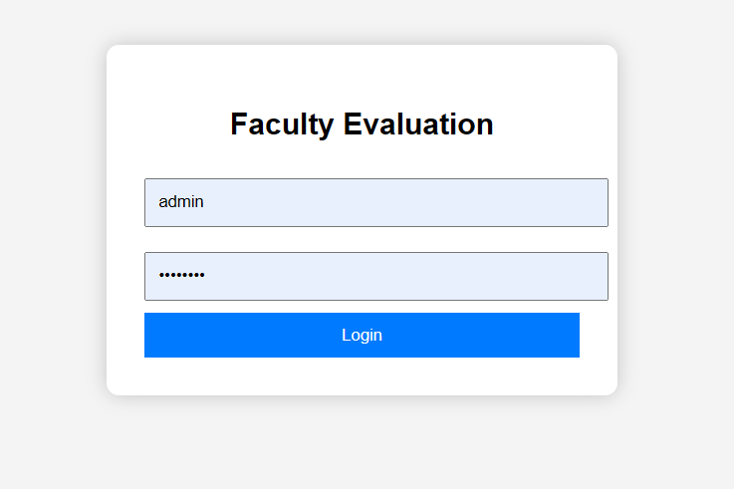
Figure 6.1. Login Page

Step 2 – User Authentication
The user enters a valid username and password. The system validates the credentials against the database.
- If the credentials are valid, the user is granted access.
- If the credentials are invalid, an error message is displayed and the user is prompted to try again.
Figure 6.2. User Login Authentication

Step 3 – Display User Dashboard
After successful authentication, the system redirects the user to the appropriate dashboard based on their assigned role.
- Administrator Dashboard
- Student Dashboard
Each dashboard displays only the features that the logged-in user is authorized to access.
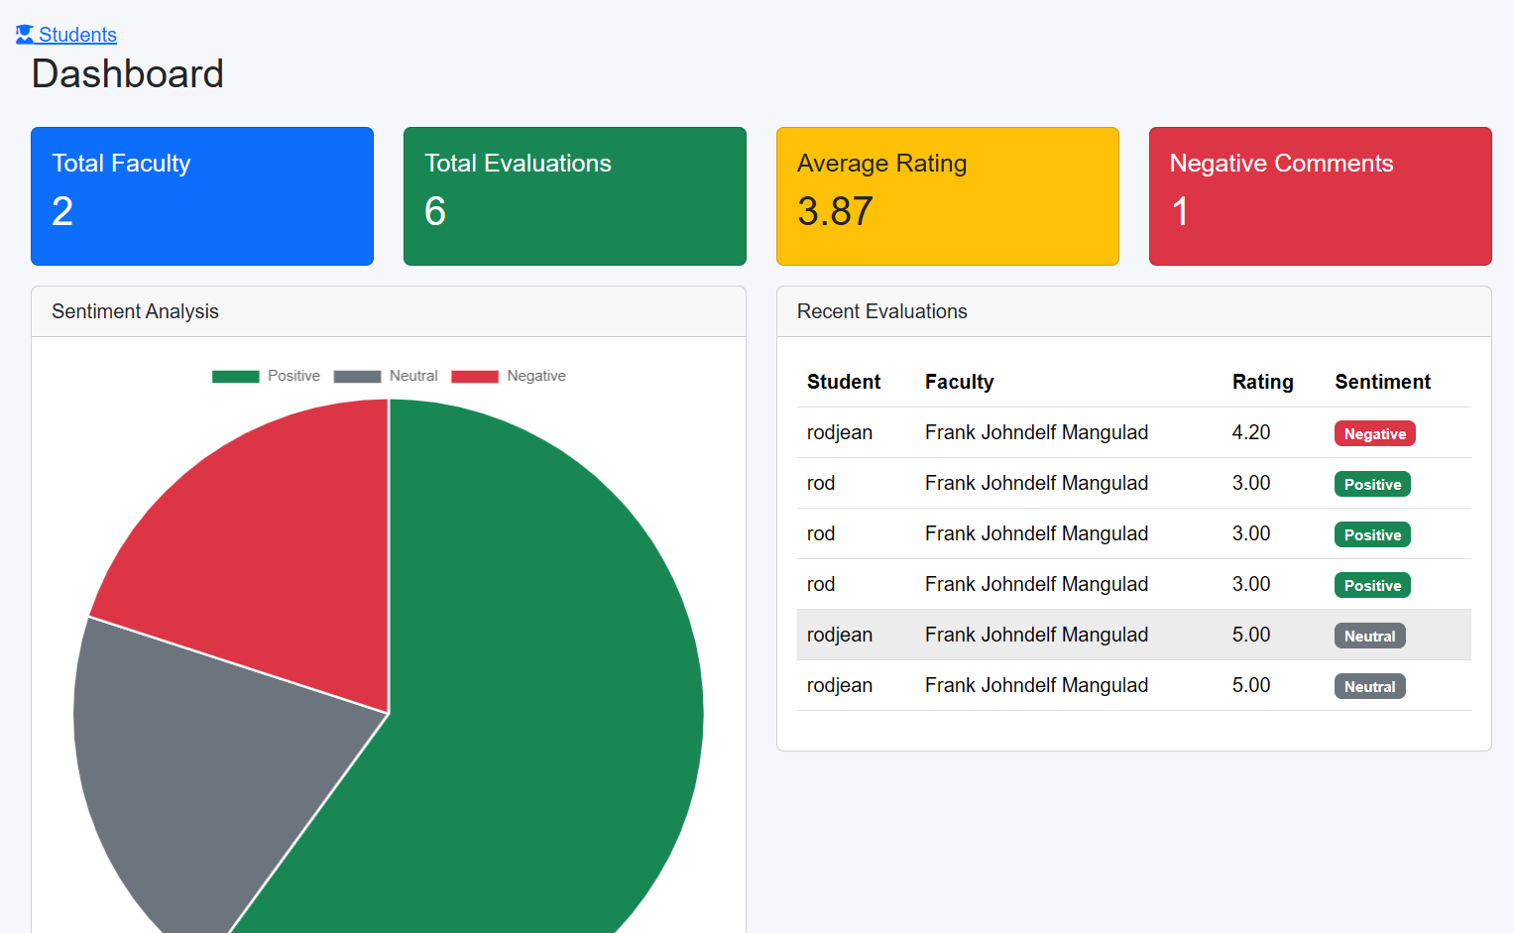
Figure 6.3. User Dashboard

Step 4 – Select Desired Module
The user selects one of the available system modules from the navigation menu.
Examples include:
- Faculty Management
- Student Management
- Evaluation
- Reports
- Analytics
- Rankings
The system loads the selected module and retrieves the necessary information from the database.
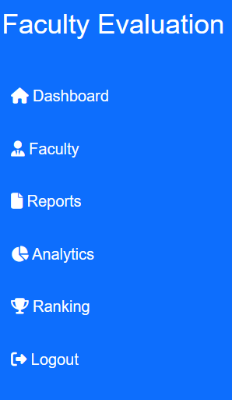
Figure 6.4. Navigation Menu

Step 5 – Perform System Operations
Depending on the selected module, the user performs specific operations.
Administrator
The administrator may:
- Add new faculty records.
- Update faculty information.
- Delete faculty records.
- Manage student accounts.
- View evaluation results.
- Generate reports.
- Monitor analytics.
- Manage user accounts.
Student
The student may:
- View assigned faculty.
- Complete evaluation forms.
- Submit evaluation responses.
- Update personal profile (if applicable).
The system validates every submitted transaction before storing it in the database.
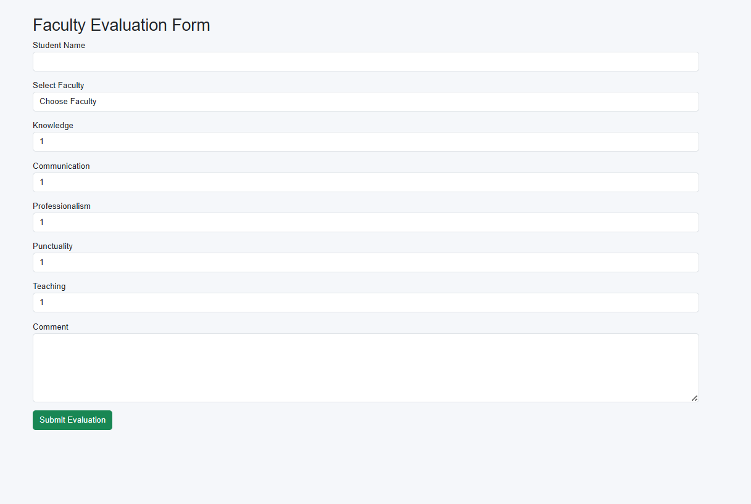
Figure 6.5. Module Operations

Step 6 – Database Processing
Once an operation is confirmed, the system processes the request by:
- Validating the submitted information.
- Executing the appropriate database query.
- Saving, updating, or retrieving records.
- Returning the corresponding result to the user interface.
This ensures that all information remains accurate and consistent within the database.
Figure 6.6. Database Transaction

Step 7 – Display Results
After processing, the system displays the updated information or confirmation message.
Examples include:
- Record Successfully Added
- Record Successfully Updated
- Evaluation Successfully Submitted
- Report Generated Successfully
The user may continue performing additional operations or return to the dashboard.
Figure 6.7. Successful Transaction

Step 8 – Logout
After completing all required tasks, the user clicks the Logout button.
The system securely ends the user's session and redirects them back to the Login page.
Figure 6.8. Logout Screen

Program Flow Summary
The overall workflow of the Faculty Evaluation System can be summarized as follows:
- Open the Faculty Evaluation System.
- Enter user credentials.
- Authenticate the user.
- Display the appropriate dashboard.
- Select the desired module.
- Perform the required operation.
- Validate and process the request.
- Store or retrieve data from the database.
- Display the operation result.
- Repeat additional tasks if necessary.
- Logout from the system.
